Ex. No:1 - Basic UNIX Commands Date:
Aim
To study and practice basic UNIX commands for navigating the terminal, file manipulation, and changing file permissions.

Navigation Commands
  - pwd - Print the current working directory
  - ls, ls -l, ls -a, ls -la - List directory contents (long format, hidden files)
  - cd <dir>, cd .., cd ~, cd - Change directory (parent, home, previous)
  - mkdir <dir> - Create a new directory
  - rmdir <dir> - Remove an empty directory

File Manipulation Commands
  - touch file.txt - Create an empty file / update its timestamp
  - cat file.txt - Display file contents
  - cp source.txt dest.txt - Copy a file
  - mv old.txt new.txt - Rename or move a file
  - rm file.txt - Delete a file (rm -r to delete a directory recursively)
  - cat file1 file2 > merged.txt - Concatenate files into a new file
  - head -n 5 file.txt / tail -n 5 file.txt - View first/last 5 lines
  - wc -l file.txt - Count lines, words, and characters in a file
  - grep "pattern" file.txt - Search for a pattern inside a file

Changing File Permissions
  - ls -l file.txt - View permissions (e.g. -rwxr--r--)
  - chmod 755 file.txt - Set permissions numerically (owner=rwx, group=rx, others=rx)
  - chmod u+x file.txt - Add execute permission for the owner (symbolic form)
  - chmod g-w file.txt - Remove write permission for the group
  - chmod o=r file.txt - Set 'others' permission to read-only
  - chown user:group file.txt - Change file owner and group

Sample Output
$ pwd
/home/student/oslab
$ mkdir test_dir && cd test_dir
$ touch a.txt b.txt
$ ls -l total 0
-rw-r--r-- 1 student student 0 Jul 16 10:00 a.txt
-rw-r--r-- 1 student student 0 Jul 16 10:00 b.txt
$ chmod 755 a.txt
$ ls -l a.txt

Result
-rwxr-xr-x 1 student student 0 Jul 16 10:00 a.txt
$ echo "Hello OS Lab" > a.txt
$ cat a.txt Hello OS Lab
$ cp a.txt c.txt
$ mv c.txt d.txt
$ ls
a.txt b.txt d.txt

Basic UNIX navigation, file manipulation, and permission-changing commands were studied and practiced successfully.

Ex. No. 2 - Implementation of fork(), exec() and wait() System Calls Date:
Aim
To write a C program that demonstrates process creation using fork(), replacing a process image using exec(), and process synchronization between parent and child using wait().

Algorithm
- Print the parent process ID using getpid().
- Create a child process using fork().
- In the child process, print its PID and parent PID, then replace its process image with the 'ls -l' command using execlp().
- In the parent process, wait for the child to terminate using wait(&status).
- Check the exit status of the child using WIFEXITED and WEXITSTATUS macros.
- Print a completion message from the parent process.

Program
#include <stdio.h> #include <stdlib.h> #include <unistd.h> #include <sys/wait.h> int main(){
pid_t pid; int status;
printf("Parent process: PID = %d\n", getpid()); pid = fork();
if (pid < 0) { perror("fork failed"); exit(1);
}
else if (pid == 0) {
printf("Child process: PID = %d, Parent PID = %d\n",getpid(), getppid()); printf("Child is about to execute 'ls -l' using execlp()\n");
execlp("ls", "ls", "-l", NULL); perror("execlp failed"); exit(1);
}
else {
printf("Parent waiting for child (PID = %d) to finish...\n", pid); wait(&status);
if (WIFEXITED(status))

printf("Child terminated normally with exit code %d\n", WEXITSTATUS(status));
else
printf("Child terminated abnormally\n");

printf("Parent process finished execution.\n");
}
return 0;
}

Sample Output

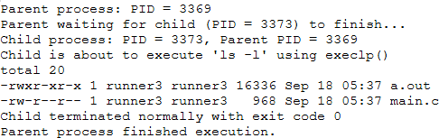

Result
The fork(), exec() and wait() system calls were implemented successfully; the child process replaced its image and the parent correctly synchronized with its completion.

Ex. No. 3 - File Copy using open(), read() and write() System Calls Date:
Aim
To write a C program that copies the contents of one file to another using the low-level UNIX system calls open(), read() and write().

Algorithm
- Accept the source and destination file names.
- Open the source file in read-only mode using open().
- Create/open the destination file in write mode (O_CREAT | O_TRUNC) with permission 0644.
- Repeatedly read a block of data from the source file using read() and write it to the destination file using write().
- Continue until read() returns 0 (end of file) or an error.
- Close both file descriptors and report success.

Program
#include <stdio.h> #include <stdlib.h> #include <unistd.h> #include <fcntl.h> #include <sys/stat.h> #define BUF_SIZE 1024
int main(int argc, char *argv[]){ int src_fd, dest_fd;
ssize_t n_read;
char buffer[BUF_SIZE];
char src_name[100], dest_name[100]; if (argc == 3) {
snprintf(src_name, sizeof(src_name), "%s", argv[1]); snprintf(dest_name, sizeof(dest_name), "%s", argv[2]);
} else {
printf("Enter source file name: "); scanf("%99s", src_name); printf("Enter destination file name: "); scanf("%99s", dest_name);
}
src_fd = open(src_name, O_RDONLY); if (src_fd < 0) {
perror("Error opening source file"); exit(1);

}
dest_fd = open(dest_name, O_WRONLY | O_CREAT | O_TRUNC, 0644); if (dest_fd < 0) {
perror("Error opening destination file"); close(src_fd);
exit(1);
}
while ((n_read = read(src_fd, buffer, BUF_SIZE)) > 0) { if (write(dest_fd, buffer, n_read) != n_read) {
perror("Error writing to destination file"); close(src_fd);
close(dest_fd); exit(1);
}
}
if (n_read < 0)
perror("Error reading source file"); else
printf("File '%s' copied to '%s' successfully.\n", src_name, dest_name); close(src_fd);
close(dest_fd); return 0;
}

Sample Output
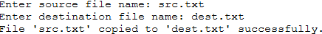

Result
The file copy program using open(), read() and write() system calls was executed successfully and the destination file matched the source file exactly.

Ex. No. 4 - CPU Scheduling - First Come First Serve (FCFS) Date:
Aim
To write a C program to simulate the FCFS CPU scheduling algorithm and compute the waiting time and turnaround time of each process.

Algorithm
- Read the number of processes, and the arrival time & burst time of each process.
- Process the processes strictly in the order they are given (FCFS order).
- Maintain a running 'completion time'; if the CPU is idle before the next process arrives, advance the completion time to that arrival time.
- Waiting time of a process = completion time (before running it) - arrival time.
- Turnaround time = completion time (after running it) - arrival time.
- Compute and display the average waiting time and average turnaround time.

Program

#include <stdio.h> int main(){
int n, i;
int bt[20], at[20], wt[20], tat[20]; float total_wt = 0, total_tat = 0; printf("Enter number of processes: "); scanf("%d", &n);
printf("Enter Arrival Time and Burst Time for each process:\n"); for (i = 0; i < n; i++) {
printf("P%d - Arrival Time: ", i + 1); scanf("%d", &at[i]);
printf("P%d - Burst Time: ", i + 1); scanf("%d", &bt[i]);
}
int completion_time = 0; printf("\nProcess\tAT\tBT\tWT\tTAT\n"); for (i = 0; i < n; i++) {
if (completion_time < at[i]) completion_time = at[i];
wt[i] = completion_time - at[i]; completion_time += bt[i];
tat[i] = completion_time - at[i]; total_wt += wt[i];

total_tat += tat[i];
printf("P%d\t%d\t%d\t%d\t%d\n", i + 1, at[i], bt[i], wt[i], tat[i]);
}
printf("\nAverage Waiting Time = %.2f\n", total_wt / n); printf("Average Turnaround Time = %.2f\n", total_tat / n);
return 0;
}

Sample Output
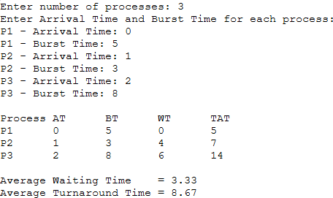

Result
The FCFS CPU scheduling algorithm was simulated successfully and the average waiting time and turnaround time were computed correctly.

Ex. No. 5 - CPU Scheduling - Shortest Job First (SJF), Non-Preemptive Date:
Aim
To write a C program to simulate the non-preemptive SJF CPU scheduling algorithm and compute the waiting time and turnaround time of each process.

Algorithm
- Read the number of processes, and the arrival time & burst time of each process.
- At every scheduling point, consider only the processes that have arrived and are not yet completed.
- Among these, select the process with the smallest burst time to run next.
- Run the selected process to completion (non-preemptive) and update its waiting time and turnaround time.
- If no process has arrived yet, advance the simulated clock (CPU idle).
- Repeat until all processes are completed, then compute the averages.

Program

#include <stdio.h> int main(){
int n, i;
int bt[20], at[20], wt[20], tat[20], done[20]; float total_wt = 0, total_tat = 0;
int completed = 0, current_time = 0; printf("Enter number of processes: "); scanf("%d", &n);
printf("Enter Arrival Time and Burst Time for each process:\n"); for (i = 0; i < n; i++) {
printf("P%d - Arrival Time: ", i + 1); scanf("%d", &at[i]);
printf("P%d - Burst Time: ", i + 1); scanf("%d", &bt[i]);
done[i] = 0;
}
while (completed != n) { int idx = -1;
int min_bt = 1000000; for (i = 0; i < n; i++) {
if (!done[i] && at[i] <= current_time) { if (bt[i] < min_bt) {

min_bt = bt[i]; idx = i;
}
}
}

if (idx == -1) { current_time++; continue;
}
wt[idx] = current_time - at[idx]; current_time += bt[idx];
tat[idx] = current_time - at[idx]; done[idx] = 1;
completed++;
}
printf("\nProcess\tAT\tBT\tWT\tTAT\n"); for (i = 0; i < n; i++) {
total_wt += wt[i]; total_tat += tat[i];
printf("P%d\t%d\t%d\t%d\t%d\n", i + 1, at[i], bt[i], wt[i], tat[i]);
}
printf("\nAverage Waiting Time = %.2f\n", total_wt / n); printf("Average Turnaround Time = %.2f\n", total_tat / n); return 0;
}

Sample Output
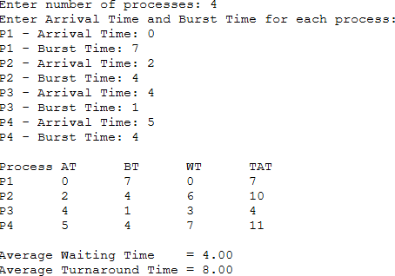

Result
The non-preemptive SJF CPU scheduling algorithm was simulated successfully and produces the minimum possible average waiting time for the given process set.

Ex. No. 6 - CPU Scheduling - Round Robin Date:
Aim
To write a C program to simulate the Round Robin CPU scheduling algorithm for a given time quantum and compute the waiting time and turnaround time of each process.

Algorithm
- Read the number of processes, their arrival time, burst time, and the time quantum.
- Maintain a ready queue. Initially enqueue all processes that arrive at time 0.
- Repeatedly dequeue the process at the front of the queue and run it for min(time quantum, remaining burst time).
- If new processes arrive during this time slice, enqueue them before re-queueing the running process (if it has remaining burst time).
- If the process finishes exactly at or before the quantum expires, record its completion time and compute waiting/turnaround time.
- Continue until all processes are completed, then compute the averages.

Program
#include <stdio.h> int main(){
int n, i, tq;
int bt[20], at[20], rem_bt[20], wt[20], tat[20]; float total_wt = 0, total_tat = 0;
printf("Enter number of processes: "); scanf("%d", &n);
printf("Enter Arrival Time and Burst Time for each process:\n"); for (i = 0; i < n; i++) {
printf("P%d - Arrival Time: ", i + 1); scanf("%d", &at[i]);
printf("P%d - Burst Time: ", i + 1); scanf("%d", &bt[i]);
rem_bt[i] = bt[i];
}
printf("Enter Time Quantum: "); scanf("%d", &tq);
int current_time = 0, completed = 0; int queue[1000], front = 0, rear = 0; int in_queue[20] = {0};
for (i = 0; i < n; i++) {
if (at[i] <= current_time && !in_queue[i]) {

queue[rear++] = i; in_queue[i] = 1;
}
}

while (completed != n) { if (front == rear) {
current_time++;
for (i = 0; i < n; i++)
if (at[i] <= current_time && !in_queue[i] && rem_bt[i] > 0) { queue[rear++] = i;
in_queue[i] = 1;
}
continue;
}
int idx = queue[front++]; if (rem_bt[idx] > tq) {
current_time += tq; rem_bt[idx] -= tq;
} else {
current_time += rem_bt[idx];
wt[idx] = current_time - at[idx] - bt[idx]; tat[idx] = current_time - at[idx]; rem_bt[idx] = 0;
completed++;
}
for (i = 0; i < n; i++)
if (at[i] <= current_time && !in_queue[i] && rem_bt[i] > 0) { queue[rear++] = i;
in_queue[i] = 1;
}
if (rem_bt[idx] > 0) queue[rear++] = idx;
}
printf("\nProcess\tAT\tBT\tWT\tTAT\n"); for (i = 0; i < n; i++) {
total_wt += wt[i]; total_tat += tat[i];
printf("P%d\t%d\t%d\t%d\t%d\n", i + 1, at[i], bt[i], wt[i], tat[i]);
}
printf("\nAverage Waiting Time = %.2f\n", total_wt / n); printf("Average Turnaround Time = %.2f\n", total_tat / n); return 0;
}

Sample Output

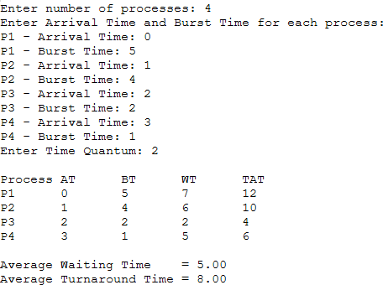

Result
The Round Robin CPU scheduling algorithm was simulated successfully for the given time quantum, with fair time-sliced execution among all processes.

Ex. No. 7 - CPU Scheduling - Priority Scheduling (Non-Preemptive) Date:
Aim
To write a C program to simulate the non-preemptive priority CPU scheduling algorithm and compute the waiting time and turnaround time of each process.

Algorithm
- Read the number of processes along with arrival time, burst time and priority (a smaller number denotes a higher priority) of each.
- At every scheduling point, consider processes that have arrived and are not yet completed.
- Select the process with the highest priority (smallest priority number); break ties using arrival time.
- Run the selected process to completion and compute its waiting time and turnaround time.
- If no process has arrived yet, advance the simulated clock.
- Repeat until all processes are completed, then compute the averages.

Program
#include <stdio.h> int main(){
int n, i;
int bt[20], at[20], pr[20], wt[20], tat[20], done[20]; float total_wt = 0, total_tat = 0;
int completed = 0, current_time = 0; printf("Enter number of processes: "); scanf("%d", &n);
printf("Enter Arrival Time, Burst Time and Priority (lower value = higher priority):\n"); for (i = 0; i < n; i++) {
printf("P%d - Arrival Time: ", i + 1); scanf("%d", &at[i]);
printf("P%d - Burst Time: ", i + 1); scanf("%d", &bt[i]);
printf("P%d - Priority: ", i + 1); scanf("%d", &pr[i]);
done[i] = 0;
}
while (completed != n) { int idx = -1;
int best_pr = 1000000; for (i = 0; i < n; i++) {
if (!done[i] && at[i] <= current_time) {

if (pr[i] < best_pr ||
(pr[i] == best_pr && idx != -1 && at[i] < at[idx])) { best_pr = pr[i];
idx = i;
}
}
}
if (idx == -1) { current_time++; continue;
}
wt[idx] = current_time - at[idx]; current_time += bt[idx];
tat[idx] = current_time - at[idx]; done[idx] = 1;
completed++;
}
printf("\nProcess\tAT\tBT\tPriority\tWT\tTAT\n"); for (i = 0; i < n; i++) {
total_wt += wt[i]; total_tat += tat[i];
printf("P%d\t%d\t%d\t%d\t\t%d\t%d\n", i + 1, at[i], bt[i], pr[i], wt[i], tat[i]);
}
printf("\nAverage Waiting Time = %.2f\n", total_wt / n); printf("Average Turnaround Time = %.2f\n", total_tat / n); return 0;
}

Sample Output
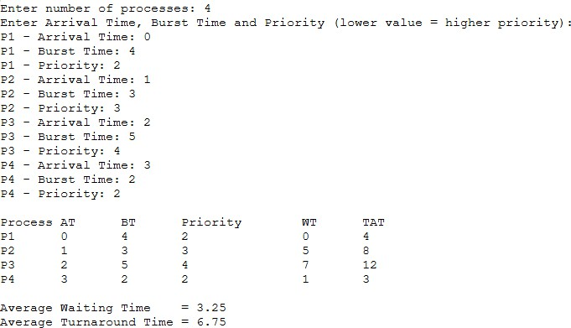

Result
The non-preemptive priority CPU scheduling algorithm was simulated successfully, executing higher-priority processes first among the arrived processes.

Ex. No. 8 - Process Synchronization - Producer-Consumer Problem using Semaphores Date:
Aim
To write a C program using POSIX threads and semaphores to solve the bounded-buffer Producer-Consumer problem, ensuring mutual exclusion and correct synchronization between the producer and consumer.

Algorithm
- Declare a bounded circular buffer of fixed size along with two counting semaphores: 'empty' (initialized to buffer size) and 'full' (initialized to 0), and a mutex lock.
- Producer: wait on 'empty', lock the mutex, insert an item into the buffer, unlock the mutex, and signal 'full'.
- Consumer: wait on 'full', lock the mutex, remove an item from the buffer, unlock the mutex, and signal 'empty'.
- Create the producer and consumer as separate POSIX threads using pthread_create().
- Join both threads using pthread_join() and destroy the semaphores and mutex.

Program
#include <stdio.h> #include <stdlib.h> #include <unistd.h> #include <pthread.h> #include <semaphore.h> #define BUFFER_SIZE 5
#define ITEMS_TO_PRODUCE 10 int buffer[BUFFER_SIZE];
int in = 0, out = 0;
sem_t empty; /* counts empty slots */ sem_t full; /* counts filled slots */
pthread_mutex_t mutex; /* protects buffer access */ void *producer(void *arg){
int item;
for (item = 1; item <= ITEMS_TO_PRODUCE; item++) { sem_wait(&empty); /* wait for an empty slot */ pthread_mutex_lock(&mutex); /* enter critical section */ buffer[in] = item;
printf("Producer produced item %d at slot %d\n", item, in); in = (in + 1) % BUFFER_SIZE;
pthread_mutex_unlock(&mutex); /* leave critical section */ sem_post(&full); /* signal a new filled slot */

usleep(100000); /* simulate production time */
}
return NULL;
}

void *consumer(void *arg){ int item;
for (int count = 1; count <= ITEMS_TO_PRODUCE; count++) { sem_wait(&full); /* wait for a filled slot */ pthread_mutex_lock(&mutex); /* enter critical section */ item = buffer[out];
printf("\tConsumer consumed item %d from slot %d\n", item, out); out = (out + 1) % BUFFER_SIZE;
pthread_mutex_unlock(&mutex); /* leave critical section */ sem_post(&empty); /* signal a new empty slot */ usleep(150000); /* simulate consumption time */
}
return NULL;
}
int main(){
pthread_t prod_thread, cons_thread;
sem_init(&empty, 0, BUFFER_SIZE); /* initially all slots empty */ sem_init(&full, 0, 0); /* initially no slots filled */ pthread_mutex_init(&mutex, NULL); pthread_create(&prod_thread, NULL, producer, NULL); pthread_create(&cons_thread, NULL, consumer, NULL); pthread_join(prod_thread, NULL);
pthread_join(cons_thread, NULL); sem_destroy(&empty); sem_destroy(&full); pthread_mutex_destroy(&mutex);
printf("\nAll items produced and consumed successfully.\n"); return 0;
}

Sample Output

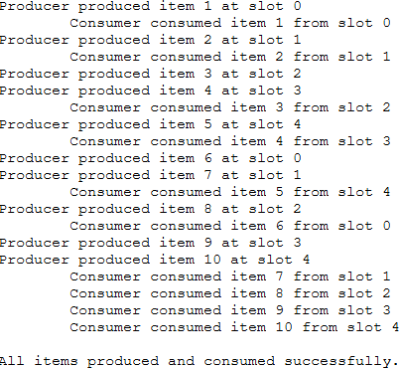

Result
The Producer-Consumer problem was solved successfully using POSIX semaphores and threads, with no buffer overflow, underflow, or race conditions observed.

Ex. No. 9 - Process Synchronization - Dining Philosophers Problem using Semaphores Date:
Aim
To write a C program using POSIX threads and semaphores to solve the Dining Philosophers problem while avoiding deadlock.

Algorithm
- Represent each of the 5 forks as a binary semaphore, initialized to 1 (available).
- Introduce an additional counting semaphore 'room' initialized to N-1 (one less than the number of philosophers) to prevent all philosophers from picking up a fork simultaneously - this breaks the circular-wait condition and avoids deadlock.
- Each philosopher thread repeatedly: thinks, then waits on 'room', picks up the left fork semaphore, picks up the right fork semaphore, eats, releases both fork semaphores, and finally releases 'room'.
- Create all philosopher threads using pthread_create() and join them using pthread_join().
- Destroy all semaphores after all philosophers have finished eating the required number of times.

Program
#include <stdio.h> #include <stdlib.h> #include <unistd.h> #include <pthread.h> #include <semaphore.h> #define N 5
#define MEALS 3 sem_t forks[N]; sem_t room;
void think(int id){
printf("Philosopher %d is thinking.\n", id); usleep(100000);
}
void eat(int id){
printf("Philosopher %d is eating.\n", id); usleep(100000);
}
void *philosopher(void *arg){ int id = *(int *)arg;
int left = id;
int right = (id + 1) % N;
for (int m = 0; m < MEALS; m++) {

think(id); sem_wait(&room); sem_wait(&forks[left]);
printf("Philosopher %d picked up left fork %d\n", id, left); sem_wait(&forks[right]);
printf("Philosopher %d picked up right fork %d\n", id, right);
eat(id); sem_post(&forks[right]); sem_post(&forks[left]);
printf("Philosopher %d put down both forks.\n", id); sem_post(&room);
}
return NULL;
}
int main(){ pthread_t phil[N]; int ids[N];
for (int i = 0; i < N; i++) sem_init(&forks[i], 0, 1);
sem_init(&room, 0, N - 1); for (int i = 0; i < N; i++) {
ids[i] = i;
pthread_create(&phil[i], NULL, philosopher, &ids[i]);
}
for (int i = 0; i < N; i++) pthread_join(phil[i], NULL);
for (int i = 0; i < N; i++) sem_destroy(&forks[i]);
sem_destroy(&room);
printf("\nAll philosophers have finished eating. No deadlock occurred.\n"); return 0;
}

Sample Output
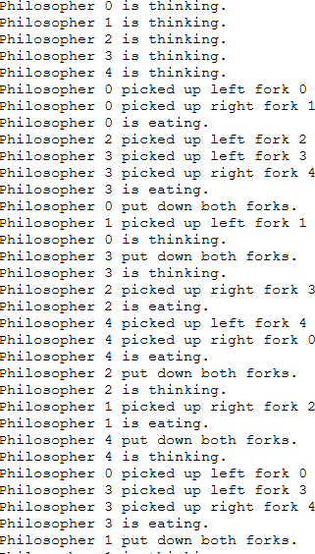
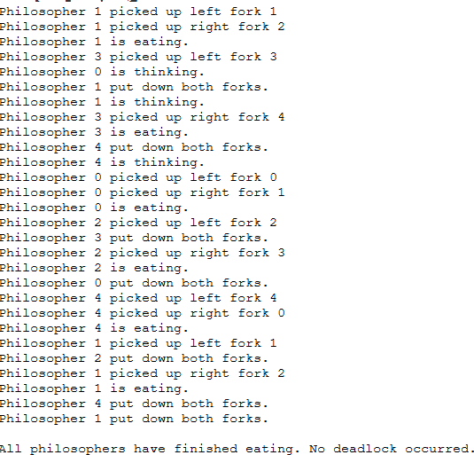

Result
The Dining Philosophers problem was solved successfully using semaphores; the 'room' semaphore prevented circular wait, and no deadlock occurred during execution.

Ex. No. 10 - Deadlock Avoidance - Banker's Algorithm Date:
Aim
To write a C program to implement the Banker's Algorithm for deadlock avoidance - to check whether a system is in a safe state and to process resource requests from processes safely.

Algorithm
- Read the Allocation matrix, Maximum matrix and Available resources vector for P processes and R resource types.
- Compute the Need matrix as Need[i][j] = Max[i][j] - Allocation[i][j].
- Safety algorithm: initialize Work = Available and Finish[i] = false for all processes. Repeatedly find a process i with Finish[i] = false and Need[i] <= Work; if found, add its Allocation to Work, mark Finish[i] = true, and add it to the safe sequence.
- If all processes are marked finished, the system is in a safe state; otherwise it is unsafe (deadlock may occur).
- Resource-request algorithm: for a request from process P, verify Request <= Need and Request
<= Available; tentatively allocate the resources, re-run the safety algorithm, and grant the request only if the resulting state is safe (otherwise roll back and deny it).

Program
#include <stdio.h> #define P 5
#define R 3
int allocation[P][R]; int max[P][R];
int need[P][R]; int available[R];
void calculate_need(){ int i, j;
for (i = 0; i < P; i++) for (j = 0; j < R; j++)
need[i][j] = max[i][j] - allocation[i][j];
}
int is_safe(int safe_seq[]){ int work[R];
int finish[P] = {0}; int i, j, count = 0;
for (i = 0; i < R; i++) work[i] = available[i];
while (count < P) {

int found = 0;
for (i = 0; i < P; i++) { if (!finish[i]) {
int can_allocate = 1; for (j = 0; j < R; j++) {
if (need[i][j] > work[j]) { can_allocate = 0; break;
}
}
if (can_allocate) {
for (j = 0; j < R; j++)
work[j] += allocation[i][j]; safe_seq[count++] = i; finish[i] = 1;
found = 1;
}
}
}
if (!found)
return 0; /* no process could proceed -> unsafe */
}
return 1;
}
int request_resources(int p_id, int request[R]){ int i;
int safe_seq[P];
for (i = 0; i < R; i++) {
if (request[i] > need[p_id][i]) {
printf("Error: Process P%d has exceeded its maximum claim.\n", p_id); return 0;
}
}
for (i = 0; i < R; i++) {
if (request[i] > available[i]) {
printf("Process P%d must wait; resources are not available.\n", p_id); return 0;
}
}
for (i = 0; i < R; i++) { available[i] -= request[i];
allocation[p_id][i] += request[i]; need[p_id][i] -= request[i];
}

if (is_safe(safe_seq)) {
printf("Request can be granted safely.\nNew safe sequence: "); for (i = 0; i < P; i++)
printf("P%d ", safe_seq[i]); printf("\n");
return 1;
} else {
for (i = 0; i < R; i++) { available[i] += request[i]; allocation[p_id][i] -= request[i]; need[p_id][i] += request[i];
}
printf("Request denied: granting it would leave the system in an unsafe state.\n"); return 0;
}
}
int main(){ int i, j;
printf("Enter Allocation matrix (%d processes x %d resources):\n", P, R); for (i = 0; i < P; i++) {
printf("P%d: ", i); for (j = 0; j < R; j++)
scanf("%d", &allocation[i][j]);
}
printf("Enter Maximum matrix (%d processes x %d resources):\n", P, R); for (i = 0; i < P; i++) {
printf("P%d: ", i); for (j = 0; j < R; j++)
scanf("%d", &max[i][j]);
}
printf("Enter Available resources vector (%d resources):\n", R); for (j = 0; j < R; j++)
scanf("%d", &available[j]); calculate_need(); printf("\nNeed matrix:\n"); for (i = 0; i < P; i++) {
printf("P%d: ", i); for (j = 0; j < R; j++)
printf("%d ", need[i][j]); printf("\n");
}
int safe_seq[P];
if (is_safe(safe_seq)) {
printf("\nSystem is in a SAFE state.\nSafe sequence: ");

for (i = 0; i < P; i++) printf("P%d ", safe_seq[i]);
printf("\n");
} else {
printf("\nSystem is in an UNSAFE state (deadlock may occur).\n"); return 0;
}
int p_id;
int request[R];
printf("\nEnter process number requesting resources: "); scanf("%d", &p_id);
printf("Enter request vector (%d resources): ", R); for (j = 0; j < R; j++)
scanf("%d", &request[j]); request_resources(p_id, request); return 0;
}

Sample Output
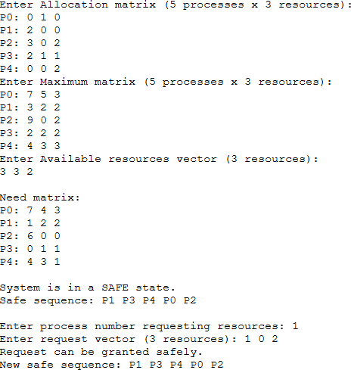

Result
The Banker's Algorithm correctly identified the system as being in a safe state with sequence <P1, P3, P4, P0, P2>, and correctly evaluated a resource request without leading to deadlock. These results match the standard textbook example.

Ex. No. 11 - Memory Management - Contiguous Allocation (First Fit, Best Fit, Worst Fit) Date:
Aim
To write a C program to simulate First Fit, Best Fit and Worst Fit contiguous memory allocation strategies for a given set of memory blocks and processes.

Algorithm
- Read the number and sizes of the available memory blocks (partitions), and the number and sizes of the processes to be allocated.
- First Fit: for each process, scan the blocks in order and allocate it to the first block whose size is greater than or equal to the process size.
- Best Fit: for each process, scan all blocks and allocate it to the smallest block that is still large enough (minimizes leftover space).
- Worst Fit: for each process, scan all blocks and allocate it to the largest available block (maximizes leftover space).
- For each strategy, reduce the chosen block's remaining size by the allocated process size and display the block-to-process allocation table.

Program
#include <stdio.h> #include <string.h> #define MAX 20
void first_fit(int bsize[], int nb, int psize[], int np){ int block[MAX], allocation[MAX];
int i, j;
for (i = 0; i < nb; i++) block[i] = bsize[i]; /* remaining size of each block */ for (i = 0; i < np; i++) allocation[i] = -1;
for (i = 0; i < np; i++) { for (j = 0; j < nb; j++) {
if (block[j] >= psize[i]) { allocation[i] = j; block[j] -= psize[i]; break;
}
}
}
printf("\n--- First Fit ---\n"); printf("Process\tSize\tBlock Allocated\n"); for (i = 0; i < np; i++) {
if (allocation[i] != -1)

printf("P%d\t%d\tBlock %d\n", i + 1, psize[i], allocation[i] + 1); else
printf("P%d\t%d\tNot Allocated\n", i + 1, psize[i]);
}
}

void best_fit(int bsize[], int nb, int psize[], int np){ int block[MAX], allocation[MAX];
int i, j;
for (i = 0; i < nb; i++) block[i] = bsize[i]; for (i = 0; i < np; i++) allocation[i] = -1; for (i = 0; i < np; i++) {
int best_idx = -1;
for (j = 0; j < nb; j++) {
if (block[j] >= psize[i]) {
if (best_idx == -1 || block[j] < block[best_idx]) best_idx = j;
}
}
if (best_idx != -1) { allocation[i] = best_idx; block[best_idx] -= psize[i];
}
}

printf("\n--- Best Fit ---\n"); printf("Process\tSize\tBlock Allocated\n"); for (i = 0; i < np; i++) {
if (allocation[i] != -1)
printf("P%d\t%d\tBlock %d\n", i + 1, psize[i], allocation[i] + 1); else
printf("P%d\t%d\tNot Allocated\n", i + 1, psize[i]);
}
}

void worst_fit(int bsize[], int nb, int psize[], int np){ int block[MAX], allocation[MAX];
int i, j;

for (i = 0; i < nb; i++) block[i] = bsize[i]; for (i = 0; i < np; i++) allocation[i] = -1;

for (i = 0; i < np; i++) { int worst_idx = -1;

for (j = 0; j < nb; j++) {
if (block[j] >= psize[i]) {
if (worst_idx == -1 || block[j] > block[worst_idx]) worst_idx = j;
}
}
if (worst_idx != -1) { allocation[i] = worst_idx; block[worst_idx] -= psize[i];
}
}

printf("\n--- Worst Fit ---\n"); printf("Process\tSize\tBlock Allocated\n"); for (i = 0; i < np; i++) {
if (allocation[i] != -1)
printf("P%d\t%d\tBlock %d\n", i + 1, psize[i], allocation[i] + 1); else
printf("P%d\t%d\tNot Allocated\n", i + 1, psize[i]);
}
}
int main()
{
int nb, np, i;
int bsize[MAX], psize[MAX]; printf("Enter number of memory blocks: "); scanf("%d", &nb);
printf("Enter size of each block:\n"); for (i = 0; i < nb; i++) {
printf("Block %d: ", i + 1);
scanf("%d", &bsize[i]);
}
printf("Enter number of processes: "); scanf("%d", &np);
printf("Enter size of each process:\n"); for (i = 0; i < np; i++) {
printf("Process %d: ", i + 1); scanf("%d", &psize[i]);
}
first_fit(bsize, nb, psize, np); best_fit(bsize, nb, psize, np); worst_fit(bsize, nb, psize, np); return 0;
}

Sample Output
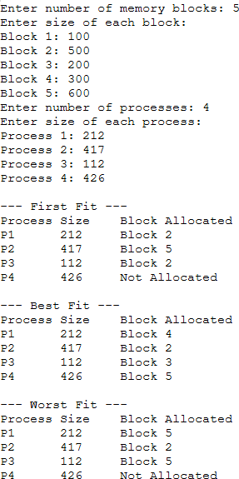

Result
First Fit, Best Fit and Worst Fit contiguous memory allocation strategies were simulated successfully; Best Fit allocated all processes, while First Fit and Worst Fit left one process unallocated for the given block/process sizes.

Ex. No. 12 - Memory Management - Page Replacement Algorithms (FIFO, LRU, Optimal)
Date:

Aim
To write a C program to simulate FIFO, LRU and Optimal page replacement algorithms for a given page reference string and number of page frames, and to compute the number of page faults for each.

Algorithm
- Read the reference string (sequence of page numbers requested) and the number of available page frames.
- FIFO: maintain the frames as a circular queue; on a page fault, replace the page that has been in memory the longest (oldest, first-in).
- LRU: on a page fault, replace the page in memory that was used least recently (using a 'last used' timestamp per frame).
- Optimal: on a page fault, replace the page whose next use is farthest in the future (or that will never be used again).
- For each algorithm, track hits/faults, print the frame contents after each reference, and report the total number of page faults.

Program

#include <stdio.h> #define MAX 50
int is_present(int frames[], int nf, int page){ int i;
for (i = 0; i < nf; i++)
if (frames[i] == page) return 1;
return 0;
}

void fifo(int ref[], int n, int nf)
{
int frames[MAX];
int i, j, faults = 0, next = 0;

for (i = 0; i < nf; i++) frames[i] = -1; printf("\n--- FIFO Page Replacement ---\n");

for (i = 0; i < n; i++) {
if (!is_present(frames, nf, ref[i])) { frames[next] = ref[i];
next = (next + 1) % nf; faults++;
printf("Page %d -> Fault \tFrames: ", ref[i]);
} else {
printf("Page %d -> Hit \tFrames: ", ref[i]);
}
for (j = 0; j < nf; j++) printf("%d ", frames[j]);
printf("\n");
}
printf("Total Page Faults (FIFO) = %d\n", faults);
}

void lru(int ref[], int n, int nf)
{
int frames[MAX], last_used[MAX]; int i, j, faults = 0;
for (i = 0; i < nf; i++) { frames[i] = -1; last_used[i] = -1; } printf("\n--- LRU Page Replacement ---\n");
for (i = 0; i < n; i++) {
if (!is_present(frames, nf, ref[i])) { int idx = -1;
for (j = 0; j < nf; j++)
if (frames[j] == -1) { idx = j; break; }

if (idx == -1) { int lru_idx = 0;
for (j = 1; j < nf; j++)
if (last_used[j] < last_used[lru_idx]) lru_idx = j;
idx = lru_idx;
}
frames[idx] = ref[i]; last_used[idx] = i; faults++;
printf("Page %d -> Fault \tFrames: ", ref[i]);
} else {

for (j = 0; j < nf; j++)

if (frames[j] == ref[i]) last_used[j] = i; printf("Page %d -> Hit \tFrames: ", ref[i]);
}
for (j = 0; j < nf; j++) printf("%d ", frames[j]);
printf("\n");
}
printf("Total Page Faults (LRU) = %d\n", faults);
}

void optimal(int ref[], int n, int nf)
{
int frames[MAX]; int i, j, k, faults = 0;

for (i = 0; i < nf; i++) frames[i] = -1;

printf("\n--- Optimal Page Replacement ---\n"); for (i = 0; i < n; i++) {
if (!is_present(frames, nf, ref[i])) { int idx = -1;
for (j = 0; j < nf; j++)
if (frames[j] == -1) { idx = j; break; }
if (idx == -1) {
int farthest = -1, replace_idx = 0; for (j = 0; j < nf; j++) {
int k_use = -1;
for (k = i + 1; k < n; k++) {
if (frames[j] == ref[k]) { k_use = k; break; }
}
if (k_use == -1) { replace_idx = j; break; } /* never used again */ if (k_use > farthest) { farthest = k_use; replace_idx = j; }
}
idx = replace_idx;
}
frames[idx] = ref[i]; faults++;
printf("Page %d -> Fault \tFrames: ", ref[i]);
} else {
printf("Page %d -> Hit \tFrames: ", ref[i]);
}
for (j = 0; j < nf; j++) printf("%d ", frames[j]);

printf("\n");
}
printf("Total Page Faults (Optimal) = %d\n", faults);
}

int main()
{
int ref[MAX], n, nf;

printf("Enter number of pages in reference string: "); scanf("%d", &n);
printf("Enter the reference string:\n"); for (int i = 0; i < n; i++)
scanf("%d", &ref[i]);
printf("Enter number of page frames: "); scanf("%d", &nf);
fifo(ref, n, nf);
lru(ref, n, nf); optimal(ref, n, nf);
return 0;
}

Sample Output
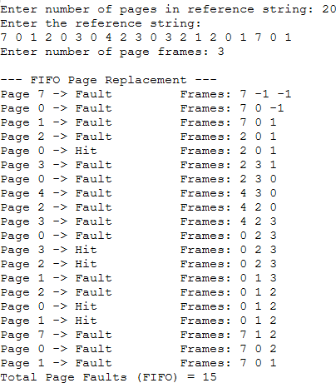

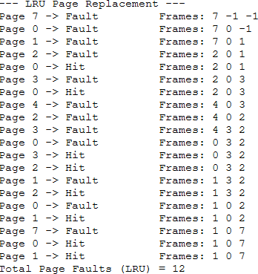

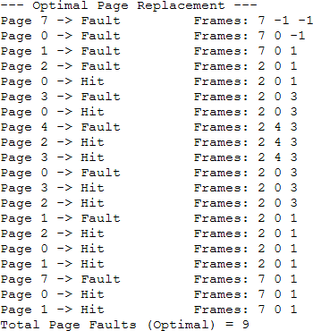

Result
FIFO, LRU and Optimal page replacement algorithms were simulated successfully for the classic reference string with 3 frames, producing 15, 12 and 9 page faults respectively - confirming that Optimal gives the fewest faults, as expected by Belady's theorem.

Ex. No. 13 - Disk Scheduling Algorithms (SSTF, SCAN, C-SCAN) Date:
Aim
To write a C program to simulate SSTF, SCAN and C-SCAN disk scheduling algorithms for a given set of disk requests and compute the total head movement (seek time) for each.

Algorithm
- Read the disk request queue (cylinder numbers), the initial head position, the disk size, and the initial direction of head movement.
- SSTF (Shortest Seek Time First): from the current head position, always service the pending request that is closest (minimum seek distance) next.
- SCAN (Elevator): sort the requests; move the head in the chosen direction servicing all requests in that direction (going all the way to the disk boundary), then reverse direction and service the remaining requests.
- C-SCAN (Circular SCAN): move the head in one direction servicing all requests up to the disk boundary, then jump directly back to cylinder 0 (this jump is not counted as seek time) and continue servicing the remaining requests in the same direction.
- For each algorithm, print the seek sequence and compute the total head movement.

Program
#include <stdio.h> #include <stdlib.h> #define MAX 100
void sstf(int req[], int n, int head)
{
int visited[MAX] = {0};
int total = 0, cur = head, i, count = 0;

printf("\n--- SSTF (Shortest Seek Time First) ---\n"); printf("Seek Sequence: %d", cur);

while (count < n) {
int min_dist = 1000000, idx = -1; for (i = 0; i < n; i++) {
if (!visited[i]) {
int dist = abs(req[i] - cur); if (dist < min_dist) {
min_dist = dist; idx = i;
}

}
}
visited[idx] = 1; total += min_dist; cur = req[idx]; printf(" -> %d", cur); count++;
}
printf("\nTotal Head Movement (SSTF) = %d\n", total);
}

int cmp(const void *a, const void *b)
{
return (*(int *)a - *(int *)b);
}

void scan(int req[], int n, int head, int disk_size, int direction)
{
int sorted[MAX]; int i;
for (i = 0; i < n; i++) sorted[i] = req[i]; qsort(sorted, n, sizeof(int), cmp);

int total = 0, cur = head;
printf("\n--- SCAN (Elevator Algorithm) ---\n"); printf("Seek Sequence: %d", cur);

if (direction == 1) { /* move up towards disk_size-1, then reverse */ for (i = 0; i < n; i++) {
if (sorted[i] >= head) { printf(" -> %d", sorted[i]); total += abs(sorted[i] - cur); cur = sorted[i];
}
}
if (cur != disk_size - 1) {
printf(" -> %d", disk_size - 1); total += abs((disk_size - 1) - cur); cur = disk_size - 1;
}
for (i = n - 1; i >= 0; i--) { if (sorted[i] < head) {
printf(" -> %d", sorted[i]); total += abs(cur - sorted[i]);

cur = sorted[i];
}
}
} else {
for (i = n - 1; i >= 0; i--) { if (sorted[i] <= head) {
printf(" -> %d", sorted[i]); total += abs(cur - sorted[i]); cur = sorted[i];
}
}
if (cur != 0) {
printf(" -> %d", 0); total += abs(cur - 0); cur = 0;
}
for (i = 0; i < n; i++) { if (sorted[i] > head) {
printf(" -> %d", sorted[i]); total += abs(sorted[i] - cur); cur = sorted[i];
}
}
}
printf("\nTotal Head Movement (SCAN) = %d\n", total);
}
void cscan(int req[], int n, int head, int disk_size)
{
int sorted[MAX]; int i;
for (i = 0; i < n; i++) sorted[i] = req[i]; qsort(sorted, n, sizeof(int), cmp);
int total = 0, cur = head;
printf("\n--- C-SCAN (Circular SCAN) ---\n"); printf("Seek Sequence: %d", cur);
for (i = 0; i < n; i++) {
if (sorted[i] >= head) { printf(" -> %d", sorted[i]); total += abs(sorted[i] - cur); cur = sorted[i];
}

}
if (cur != disk_size - 1) {
printf(" -> %d", disk_size - 1); total += abs((disk_size - 1) - cur); cur = disk_size - 1;
}
printf(" -> 0 (jump)"); cur = 0;
for (i = 0; i < n; i++) { if (sorted[i] < head) {
printf(" -> %d", sorted[i]); total += abs(sorted[i] - cur); cur = sorted[i];
}
}
printf("\nTotal Head Movement (C-SCAN) = %d\n", total);
}

int main()
{
int n, head, disk_size, i, direction; int req[MAX];

printf("Enter number of disk requests: "); scanf("%d", &n);
printf("Enter the request queue (cylinder numbers):\n"); for (i = 0; i < n; i++)
scanf("%d", &req[i]);
printf("Enter initial head position: "); scanf("%d", &head);
printf("Enter disk size (max cylinder number + 1, e.g. 200): "); scanf("%d", &disk_size);
printf("Enter initial direction for SCAN (1 = towards higher, 0 = towards lower): "); scanf("%d", &direction);
sstf(req, n, head);
scan(req, n, head, disk_size, direction); cscan(req, n, head, disk_size);
return 0;
}

Sample Output

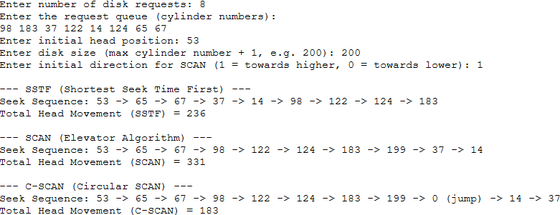

Result
SSTF, SCAN and C-SCAN disk scheduling algorithms were simulated successfully for the standard example (head=53, 200 cylinders), yielding total head movements of 236, 331 and 183 respectively, matching standard textbook values.

